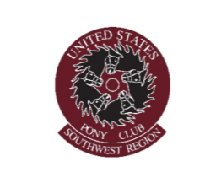
National Youth Congress letter of acceptance:

_____________________________________ of the_______________________________
Pony Club/ Riding Center has been selected as a delegate or alternate by the Regional Officers to represent the Southwest Region at the USPC National Youth Congress held in___________________________ on_____________________. S(he) is aware of the following conditions: Lodging for three nights and a portion of the meals will be paid by USPC; neither travel expenses nor the cost of registration to the USPC Equine Symposium workshops will be paid by USPC.

The region will pay a meal fee to USPC (to be determined by USPC.) This amount is generally between $200-$250. The region will reimburse a portion of the expenses accrued towards this activity with the following conditions: The expense form must be filed within 1 month of the convention accompanied by all receipts. The delegate must also provide a written report to the RS stating an overview of what was accomplished at the Youth Congress. No monies will be reimbursed without the reimbursement form and the report. The reimbursement cannot exceed the amount budgeted by the region and should not exceed $250.

S(he) acknowledges these responsibilities and agrees to these terms by providing a signature:

Name____________________________________________Date_____________________

